set statistics io on
SELECT SAC_RV_EM_POS.DT_GERACAO_PROV, SAC_RV_EM_POS.ID_MOVIMENTO FROM SAC_RV_EM_POS , SAC_RV_EMPRESTIMO_ACOES WHERE SAC_RV_EMPRESTIMO_ACOES.DT_DEPOSITO = '1-2-2012 0:0:0.000' AND ( SAC_RV_EM_POS.ID_MOVIMENTO ) = ( SAC_RV_EMPRESTIMO_ACOES.ID_MOVIMENTO ) AND ( SAC_RV_EMPRESTIMO_ACOES.CLCLI_CD = '2061' ) AND ( SAC_RV_EM_POS.SG_PROVENTO = 'F')
set statistics io off

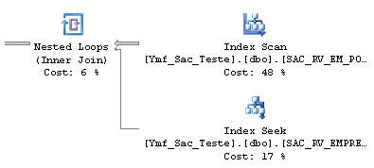

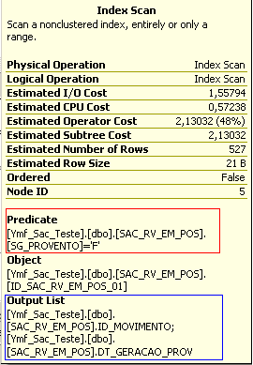

--Table 'SAC_RV_EMPRESTIMO_ACOES'. Scan count 527, logical reads 2294
Table 'SAC_RV_EM_POS'. Scan count 1, logical reads 2115

CREATE NONCLUSTERED INDEX ID_SAC_RV_EM_POS_001 ON SAC_RV_EM_POS(SG_PROVENTO)

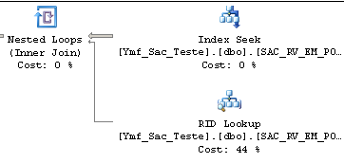

DROP INDEX ID_SAC_RV_EM_POS_001 ON SAC_RV_EM_POS
CREATE NONCLUSTERED INDEX ID_SAC_RV_EM_POS_001 ON SAC_RV_EM_POS(SG_PROVENTO)
INCLUDE (ID_MOVIMENTO,DT_GERACAO_PROV)

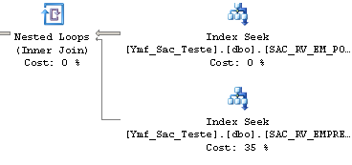

Table 'SAC_RV_EMPRESTIMO_ACOES'. Scan count 527, logical reads 2294
Table 'SAC_RV_EM_POS'. Scan count 1, logical reads 5 ( The logical reads has dropped 2115 to 5)

-- Table 'SAC_RV_EM_POS'. Scan count 1, logical reads 3

The logical readas has been the same because SQL SERVER needed to scan only 3 pages.

